**United States Department of Agriculture**

Food and Nutrition Service

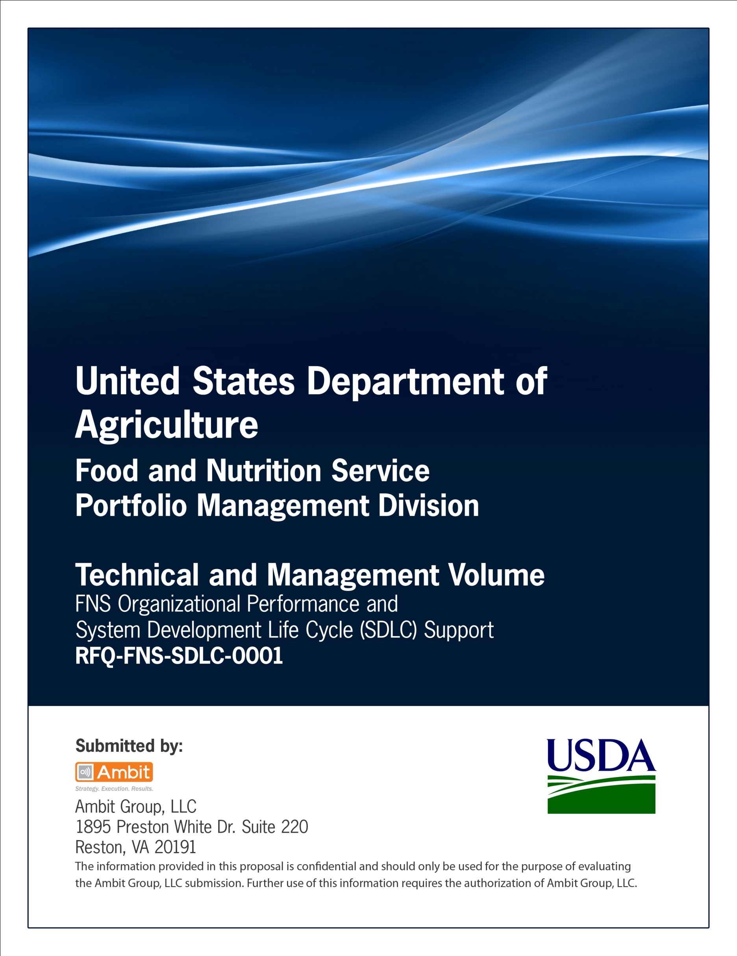

**FNS Office of Information Technology**

**Portfolio Management Division (PMD)**

**FNS System of Records Notices Template**

**(SORN)**

**for**

**[Project or System Name]**

**Version 1.1**

September 09, 2013

**Revision History**

|  |  |  |  |
| --- | --- | --- | --- |
| **Version** | **Date** | **Author** | **Change Description** |
| 1.0 | 03-12-2013 | IT Governance Branch (ITGB) | Created the document. |
| 1.1 | 09-09-2013 | IT Governance Branch (ITGB) | Re-formatted the document. |
| 1.2 |  |  |  |
| 1.3 |  |  |  |

**Contact Information**

|  |  |
| --- | --- |
| **Area of Concern** | **Contact Person** |
| IT Governance Lead | Kevin Russ |
| SDLC Coordinator | Syed Jaffery |
| ITIRB Coordinator | Sunny Dilawari |
| Portfolio Management Division Director, Chief Portfolio Officer | Jacqueline Butler |
| Program Management Branch Chief | Allison Willcox |

Contents

Glossary 4

System of Records Notices (SORN) 5

Appendix A: References 13

Approvals/Signatures 14

# 

# Glossary

| **Acronym** | **Description** |
| --- | --- |
|  |  |
|  |  |
|  |  |
|  |  |
|  |  |
|  |  |
|  |  |
|  |  |

# System of Records Notices (SORN)

UNITED STATES DEPARTMENT OF AGRICULTURE

Office of the Secretary

[Docket No. USDA/Component-XXXX]

Privacy Act of 1974;Component Name, SORN Number, Title/Name of System

System of Records

**AGENCY**: Component Name, USDA.

**ACTION**: Notice of Privacy Act system of records.

**SUMMARY**: In accordance with the Privacy Act of 1974 the Department of Agriculture proposes to establish a new Department of Agriculture system of records notice titled, Component Name, SORN Number, Insert Title of System. Include concise summary of what the system does in layman’s terms. One paragraph should be enough. No abbreviations, acronyms, or citations to legal authority in the summary. For previously published systems, add the previous SORN title, the previously published Federal Register number and date issued (Month Day, Year), areas reviewed and updated (e.g. categories of individuals, categories of records, routine uses)*.* If exemptions will be taken please include “Additionally, the Department of Agriculture is issuing a Notice of Proposed Rulemaking concurrent with this system of records elsewhere in the Federal Register.” This newly established system will be included in the Department of Agriculture’s inventory of record systems.

**DATES**: Submit comments on or before INSERT DATE 30 DAYS AFTER DATE OF PUBLICATION IN THE FEDERAL REGISTER. This new system will be effective INSERT DATE 30 DAYS AFTER PUBLICATION IN THE FEDERAL REGISTER.

**ADDRESSES:** You may submit comments, identified by docket number USDA/Component-XXXX by one of the following methods:

• Federal e-Rulemaking Portal: http://www.regulations.gov. Follow the instructions for submitting comments.

• Fax:Component POC Fax#.

• Mail:Component POC, POC Title, POC Office,Department of Agriculture, Washington, D.C. 20250.

• Instructions: All submissions received must include the agency name and docket number for this rulemaking. All comments received will be posted without change to http://www.regulations.gov, including any personal information provided.

• Docket: For access to the docket to read background documents or comments received go to http://www.regulations.gov.

**FOR FURTHER INFORMATION CONTACT**: For general questions please contact: Component POC, POC Title, POC Phone, POC Address. For privacy issues please contact: Ravoyne Payton, Chief Privacy Officer, Cyber and Privacy Policy and Oversight, Office of the Chief Information Officer, Department of Agriculture, Washington, D.C. 20250.

**SUPPLEMENTARY INFORMATION:**

I. SORN Background

Provide information about why the SORN is being published. If a PIA is being conducted in conjunction with the SORN, much of the PIA Introduction needs to be included here.

Identify whether the new system is required by a new rulemaking which is being published and state here.

Identify whether Privacy Act exemptions are being taken and state here.

Provide the reader with the Department’s rationale for why we are collecting this information and what we are doing with it.

Also provide a simplified discussion of the routine uses and possible examples.

Consistent with USDA’s information sharing mission, information stored in the Insert System Name may be shared with other USDA components, as well as appropriate Federal, State, local, tribal, foreign, or international government agencies. This sharing will only take place after USDA determines that the receiving component or agency has a need to know the information to carry out national security, law enforcement, immigration, intelligence, or other functions consistent with the routine uses set forth in this system of records notice.

Last paragraph cut-and-paste of Summary.

II. Privacy Act

The Privacy Act embodies fair information principles in a statutory framework governing the means by which the United States Government collects, maintains, uses, and disseminates individuals’ records. The Privacy Act applies to information that is maintained in a “system of records.” A “system of records” is a group of any records under the control of an agency for which information is retrieved by the name of an individual or by some identifying number, symbol, or other identifying particular assigned to the individual. In the Privacy Act, an individual is defined to encompass United States citizens and lawful permanent residents.

The Privacy Act requires each agency to publish in the Federal Register a description denoting the type and character of each system of records that the agency maintains, and the routine uses that are contained in each system in order to make agency record keeping practices transparent, to notify individuals regarding the uses to their records are put, and to assist individuals to more easily find such files within the agency. Below is the description of the Component Name, SORN Number, Insert System Name system of records.

In accordance with 5 U.S.C. 552a(r), USDA has provided a report of this system of records to the Office of Management and Budget and to Congress.

**System of Records**

USDA/Component-XXXX

**System name**:

Component, SORN Number, SORN Title (e.g. Farm Service Agency - 11 Subsidiary Personnel, Pay and Travel Records)

**Security classification**:

Insert classification (eg. Unclassified, sensitive, and classified.)

**System location**:

Records are maintained at the Component Headquarters in Washington, D.C. and field offices.

**Categories of individuals covered by the system:**

Categories of individuals covered by this system include: List the categories in a narrative.

**Categories of records in the system:**

Categories of records in this system include:

• Individual’s name;

• Date of birth;

• SSN (if collected);

• Phone numbers;

• Email addresses;

• Addresses;

SORN specific.

**Authority for maintenance of the system:**

**Purpose(s):**

The purpose of this system is insert brief description of the purpose.

**Routine uses of records maintained in the system, including categories of users and the purposes of such uses:**

In addition to those disclosures generally permitted under 5 U.S.C. 552a(b) of the Privacy Act, all or a portion of the records or information contained in this system may be disclosed outside USDA as a routine use pursuant to 5 U.S.C. 552a(b)(3) as follows:

A. To the Department of Justice (including United States Attorney Offices) or other Federal agency conducting litigation or in proceedings before any court, adjudicative or administrative body, when it is necessary to the litigation and one of the following is a party to the litigation or has an interest in such litigation:

1. USDA or any component thereof;

2. any employee of USDA in his/her official capacity;

3. any employee of USDA in his/her individual capacity where DOJ or USDA has agreed to represent the employee; or

4. the United States or any agency thereof, is a party to the litigation or has an interest in such litigation, and USDA determines that the records are both relevant and necessary to the litigation and the use of such records is compatible with the purpose for which USDA collected the records.

B. To a congressional office from the record of an individual in response to an inquiry from that congressional office made at the request of the individual to whom the record pertains.

C. To the National Archives and Records Administration or other Federal government agencies pursuant to records management inspections being conducted under the authority of 44 U.S.C. §§ 2904 and 2906.

D. To an agency, organization, or individual for the purpose of performing audit or oversight operations as authorized by law, but only such information as is necessary and relevant to such audit or oversight function.

E. To appropriate agencies, entities, and persons when:

1. Name of Agency suspects or has confirmed that the security or confidentiality of information in the system of records has been compromised;

2. The Department has determined that as a result of the suspected or confirmed compromise there is a risk of harm to economic or property interests, identity theft or fraud, or harm to the security or integrity of this system or other systems or programs (whether maintained by the Department or another agency or entity) or harm to the individual that rely upon the compromised information; and

3. The disclosure made to such agencies, entities, and persons is reasonably necessary to assist in connection with the Department’s efforts to respond to the suspected or confirmed compromise and prevent, minimize, or remedy such harm.

F. To contractors and their agents, grantees, experts, consultants, and others performing or working on a contract, service, grant, cooperative agreement, or other assignment for USDA, when necessary to accomplish an agency function related to this system of records. Individuals provided information under this routine use are subject to the same Privacy Act requirements and limitations on disclosure as are applicable to USDA officers and employees.

G. To an appropriate Federal, State, tribal, local, international, or foreign law enforcement agency or other appropriate authority charged with investigating or prosecuting a violation or enforcing or implementing a law, rule, regulation, or order, where a record, either on its face or in conjunction with other information, indicates a violation or potential violation of law, which includes criminal, civil, or regulatory violations and such disclosure is proper and consistent with the official duties of the person making the disclosure.

H.Uses-Insert any additional applicable Routine Uses for specific SORNs prior to the media Routine Use below, and adjust Routine Use lettering configuration accordingly. Do not change the order of the previous routine uses.

I. To the news media and the public, in consultation with counsel, when there exists a legitimate public interest in the disclosure of the information or when disclosure is necessary to preserve confidence in the integrity of USDA or is necessary to demonstrate the accountability of USDA’s officers, employees, or individuals covered by the system, except to the extent it is determined that release of the specific information in the context of a particular case would constitute an unwarranted invasion of personal privacy.

**Disclosure to consumer reporting agencies**:

State what information is disclosed to consumer reporting agencies. If no information is disclosed, state “None.”

**Policies and practices for storing, retrieving, accessing, retaining, and disposing of records in the system**:

**Storage**:

Records in this system are stored electronically or on paper in secure facilities in a locked drawer behind a locked door. The records are stored on magnetic disc, tape, digital media, and CD-ROM.

**Retrievability**:

Records may be retrieved byinsert retrievability fields.

**Safeguards**:

Records in this system are safeguarded in accordance with applicable rules and policies, including all applicable USDA automated systems security and access policies. Strict controls have been imposed to minimize the risk of compromising the information that is being stored. Access to the computer system containing the records in this system is limited to those individuals who have a need to know the information for the performance of their official duties and who have appropriate clearances or permissions.

**Retention and disposal**:

Insert NARA approved retention and disposal schedule. Note: Reference applicable General Records Schedule (e.g. Records are maintained for 3 years in accordance with General Records Schedule X). Please confirm with your Records Officer or USDARecords Management.

**System Manager and address**:

Insert System Manager and address. Note: The System Manager does not have to be a person; a title is preferred.

**Notification procedure**:

Individuals seeking notification of and access to any record contained in this system of records, or seeking to contest its content, may submit a request in writing to the Headquarters or component’s FOIA Officer, whose contact information can be found at http://www.da.usda.gov/foia.htm under “contacts.” If an individual believes more than one component maintains Privacy Act records concerning him or her the individual may submit the request to the Chief FOIA Officer, Department of Agriculture, 1400 Independence Avenue, S.W., Washington, D.C. 20250.

When seeking records about yourself from this system of records or any other Departmental system of records your request must conform with the Privacy Act regulations set forth in 6 CFR Part 5. You must first verify your identity, meaning that you must provide your full name, current address and date and place of birth. You must sign your request, and your signature must either be notarized or submitted under 28 U.S.C. 1746, a law that permits statements to be made under penalty of perjury as a substitute for notarization. While no specific form is required, you may obtain forms for this purpose from the Chief FOIA Officer, Department of Agriculture, 1400 Independence Avenue, S.W., Washington, D.C. 20250. In addition you should provide the following:

• An explanation of why you believe the Department would have information on you,

• Identify which component(s) of the Department you believe may have the information about you,

• Specify when you believe the records would have been created,

• Provide any other information that will help the FOIA staff determine which USDA component agency may have responsive records,

• If your request is seeking records pertaining to another living individual, you must include a statement from that individual certifying his/her agreement for you to access his/her records.

Without this bulleted information the component(s) may not be able to conduct an effective search, and your request may be denied due to lack of specificity or lack of compliance with applicable regulations.

**Record access procedures**:

See “Notification procedure” above.

**Contesting record procedures**:

See “Notification procedure” above.

**Record source categories**:

Records are obtained by insert sources.

**Exemptions claimed for the system:**

Note any exemptions claimed for the system and the applicable regulations. If you are claiming an exemption then you will need a Notice of Proposed Rulemaking pursuant to 5 USC 552(a) outlining the reasons you are doing so. If no exemptions, state, “None.”

Dated:

Tom Vilsack

Secretary

Department of Agriculture.

# Appendix A: References

Insert the name, version number, description, and physical location of any documents referenced in this document. Add rows to the table as necessary.

The following table summarizes the documents referenced in this document.

|  |  |  |
| --- | --- | --- |
| **Document Name** | **Description** | **Location** |
| Document Name and Version Number | Document description | URL or Network path where document is located |
|  |  |  |
|  |  |  |

# Approvals/Signatures

The undersigned acknowledge that they have reviewed the [name of document] document and agree with the information presented within this document. Changes to this document will be coordinated with, and approved by, the undersigned, or their designated representatives.

|  |  |  |  |
| --- | --- | --- | --- |
| Signature: |  | Date: |  |
| Print Name: |  |  |  |
| Title: |  |  |  |
| Role: | [Project or System Name] Project Manager |  |  |
|  |  |  |  |
| Signature: |  | Date: |  |
| Print Name: |  |  |  |
| Title: |  |  |  |
| Role: | [Project or System Name] Business Owner |  |  |
|  |  |  |  |
| Signature: |  | Date: |  |
| Print Name: |  |  |  |
| Title: |  |  |  |
| Role: | Organization’s Approving Authority |  |  |